**Vortex Flow Meter Transmitter Operation Manual (FC002-V2.0 Version)**

**CATALOG**

#### Product Function Specification PAGE 3

* 1. Base function
  2. Working conditions

#### Transmitter Operation And Parameter Setting .PAGE 4

* 1. Keyboard Definition and Display
  2. Transmitter Menu Structure
  3. Transmitter Parameter Description
  4. How to Setup The Parameter

#### Wiring Diagram And Output Define PAGE 17

* 1. 4-20mA Current Output Wiring Diagram
  2. Pulse Output Wiring Diagram
  3. Wiring Between Transmitter And Sensor
  4. Frequency Output Mode
  5. Pulse Equivalent Output Mode
  6. Analog Output Mode（4-20mA）

#### Key Points of Attention PAGE 20

1. **Appendix .PAGE 21**

RS485 Communication Address Table

# Product Function Specification

## Base Function

**Power Supply**

24VDC & 3.6V lithium battery(double power supply)

#### Output Signal

Current output: 4 to 20mA,load resistance：0～750Ω,Base deviation：0.1%±10μA。

Frequency output: Frequency range is 10～5000Hz；Photoelectric isolation, isolation voltage：> 1000VDC；

Pulse equivalent output: user defined pulse width,automatic conversion to square wave at high frequency Photoelectric isolation, isolation voltage：> 1000VDC；

If only 3.6v battery power supply, then without any output signal. And without communication

#### Alarm Output

Alarm output contact ： **H-ALM** and **L-ALM ;** Photoelectric isolation, isolation voltage ：> 1000VDC ； Output driver：Maximum withstand voltage 36VDC, maximum load current 30mA.

#### Communication

Communication ：RS485、HART (option)

#### LCD Display

With LCD,display flow rate , total flow , velocity and frequency etc

For two-wire output mode , then LCD display without backlight

For three-wire output mode , LCD display backlight

#### Multi-segment Nonlinear Correction Function

**Accuracy of Flow Meter:** ±0.5% of reading ; ±0.25% of reading (option)

**Compensation Function**:

With temperature and pressure compensation , display the temperature and pressure of fluid and density . The flow meter can automatically carry out the conversion of working condition and standards condition

If for liquid turbine flow meter , without this function

## Working conditions

Ambient temperature：–20～+65℃；Relative humidity：5%～90%；Fluid temperature :≤120 ℃

\

# Transmitter Operation And Parameter Setting

## Keyboard Definition and Display

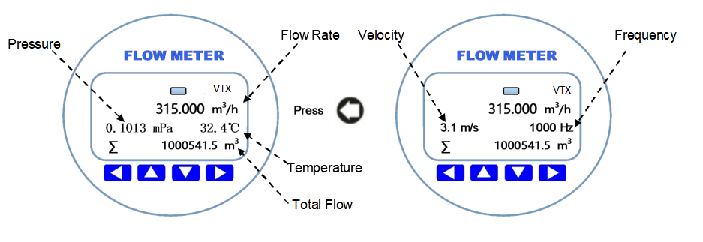

Left shift, parameter setting confirmation key and exit sub directory key

  move up and down keys

 move right, enter the parameter setting

## Transmitter Menu Structure

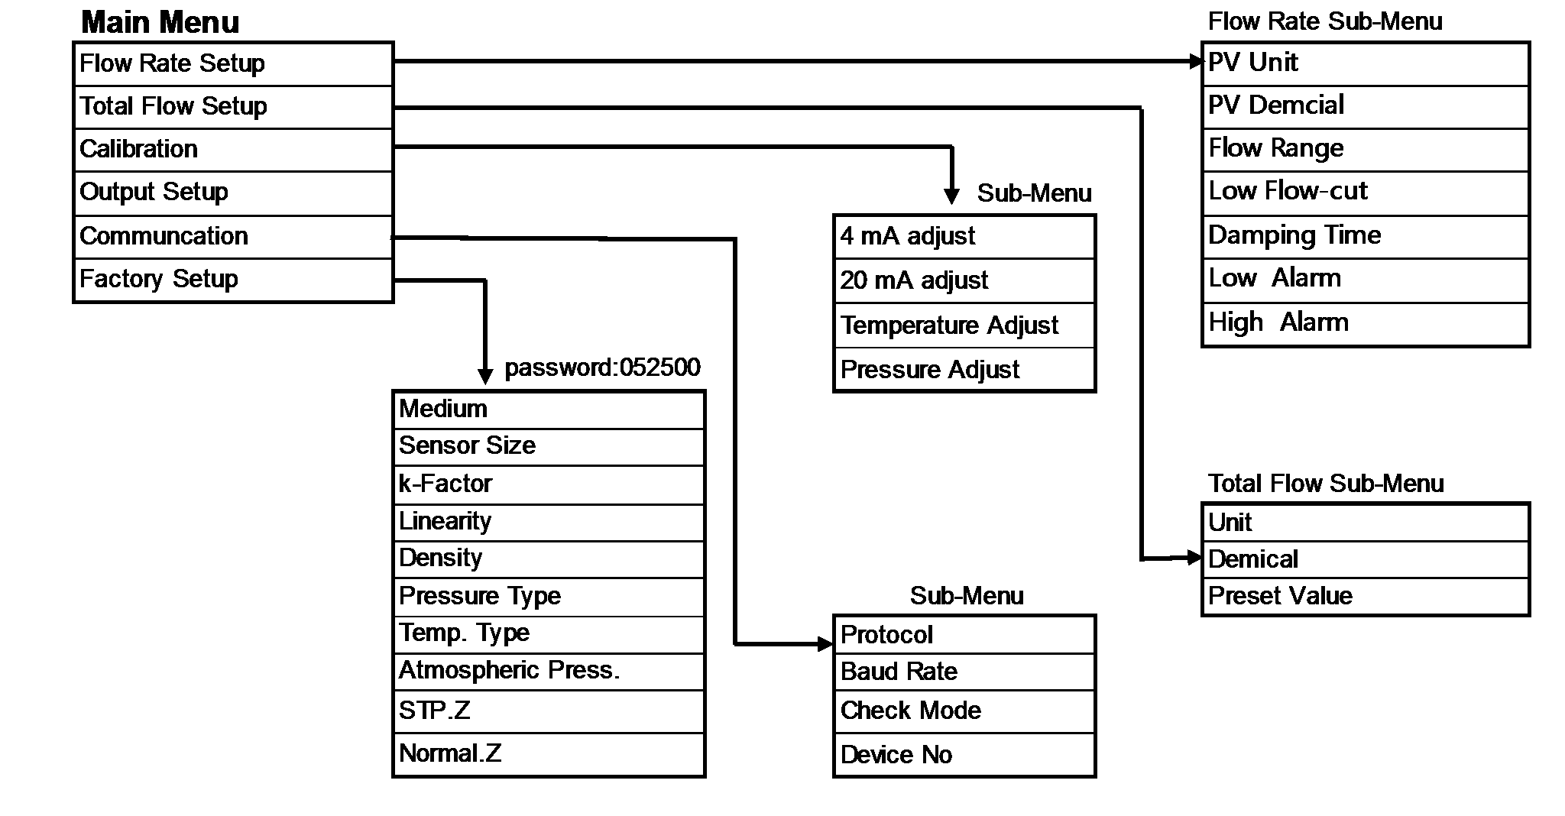

* 1. **Transmitter Parameter Description and setup**
* **Flow Rate Parameter Setting**

|  |  |  |  |  |  |  |
| --- | --- | --- | --- | --- | --- | --- |
| PV Unit | Option: **L/s L/m L/h m3/s m3/m m3/h Nm3/h USG/h Kg/s Kg/m Kg/h t/s t/m t/h**  Default = m3**/**h ；define the unit of the flow rate  L (liter), h(hour), t(ton), s(second) , m(minute) | | | | **USG/s** | **USG/m** |
| PV Decimal | Option: 0 1 2 3 ，default = 1  Define the decimal point position of the flow rate. | | | | | |
| Flow Range | Float point： 99999999.00-0.00 m3/h ，default = 100.0 m3/h When the instantaneous flow rate reaches this set value, the output  current is 20mA，Change this parameter will affect: current output, high and low flow alarm, etc。  **NOTE: when you modify the flow range , please pay attention to the flow range unit . you also can modify the flow range unit at here.** | | | | | |
| Low Flow Cut | Float point: 9.90 ～ 0.00 % ，default = The set value is a percentage.of flow range | | | 0.0 % | | |
| Damping Time | Float point: | 30.0 | ～0.1 ，default = 0.1 | | | |
| Low Alarm | Float point: 99.00 ～ 0.00 % ，default = 0.0 %  This value is a percentage of flow range. for example, if this value is setup to ten(10), then Equivalent to ten percent(10%) of flow range. If the Absolute value of instantaneous flow < (flow range × 10%),then the reansmitter willl otput the low alarm signal ,the contact of low alarm will  close 。 | | | | | |
| High Alarm | Float point: 99.00 ～ 1.00 % ，default = 90.0 %  This value is a percentage of flow range. for example, if this value is setup to ten(10), then Equivalent to ten percent(10%) of flow range. If the Absolute value of instantaneous flow > (flow range × 10%),then the reansmitter willl otput the high alarm signal ,the contact of high alarm will  close 。 | | | | | |

* **Total Flow Setup**：Define the relevant parameters of the total flow。

|  |  |
| --- | --- |
| Unit | Option： L(liter) **m³ Nm3 USG Kg t(ton)** ，  Default value ：**m³**  define the total flow unit |
| Decimal | Option : 0 1 2 3 ，Default value ： 1 define the decimal point bit of the total flow value |

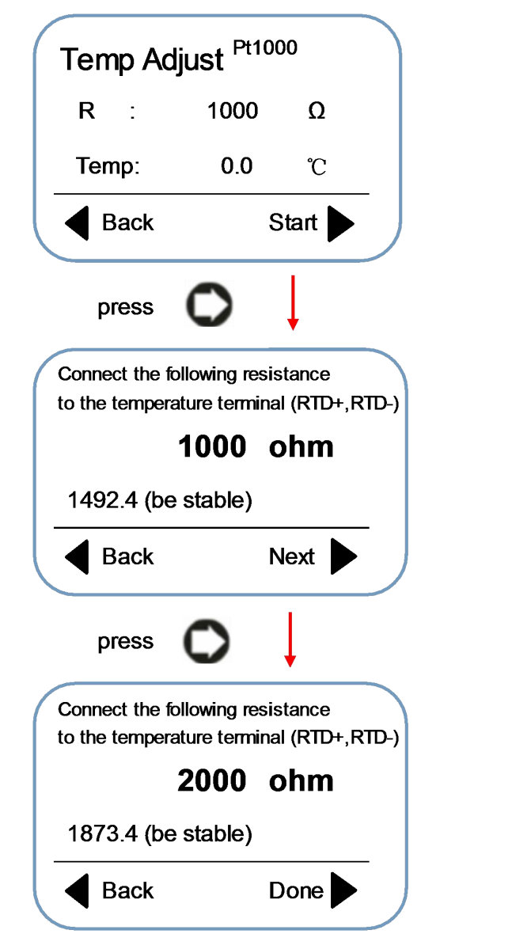

|  |  |
| --- | --- |
| Preset Value | Option: 99999999.00-0.00 m3/h ，Default = 0.0 m3/h Clear the total flow or Preser the value of the total flow |

### **Calibration**：Adjust analog current output and temperature and pressure value.

|  |  |
| --- | --- |
| 4mA adjust | Float point： 5.0～3.0 ，default = 0.0  After you go to thie item, please use the Precision current meter to measure the current output value . if this result is not 4.0mA, then input the actual value which measure to this position .then The instrument will automatically complete the calibration operation . |
| 20mA adjust | Float point： 21.0 ～19.0 ，default = 0.0  After you go to thie item, please use the Precision current meter to measure the current output value . if this result is not 20.0mA, then input the actual value which measure to this position .then The instrument will automatically complete the calibration operation . |
| Temperature Adjust (Pt100 Pt1000) | Actual Resistance Value  Actual Temperature Value  Volatge value must be stable  Press the , finishe the tempweature adjust.and back. |

Pressure Adjust

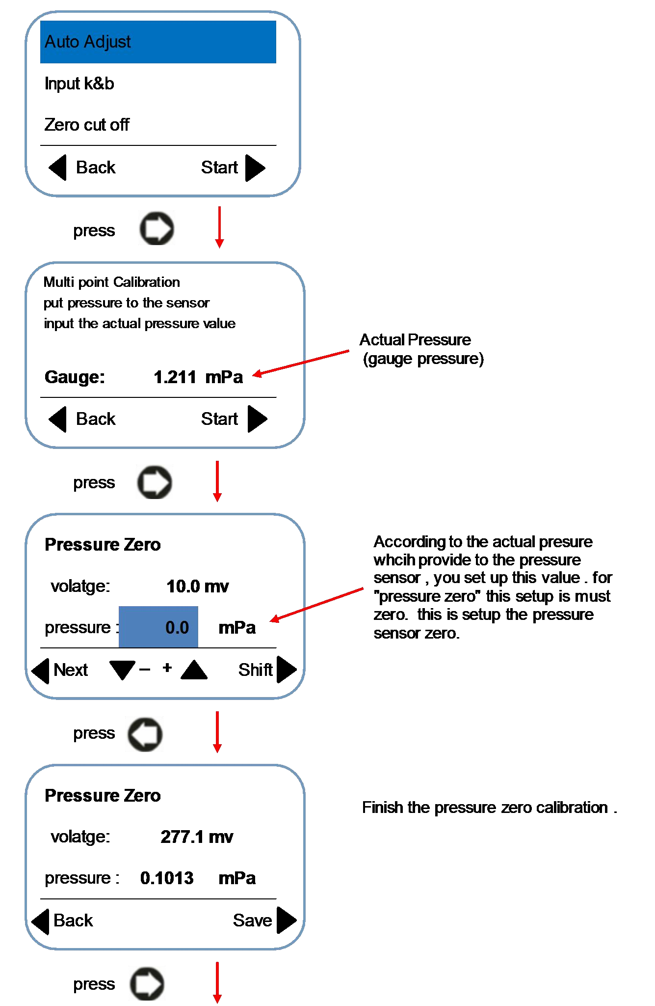

Pressure Adjust

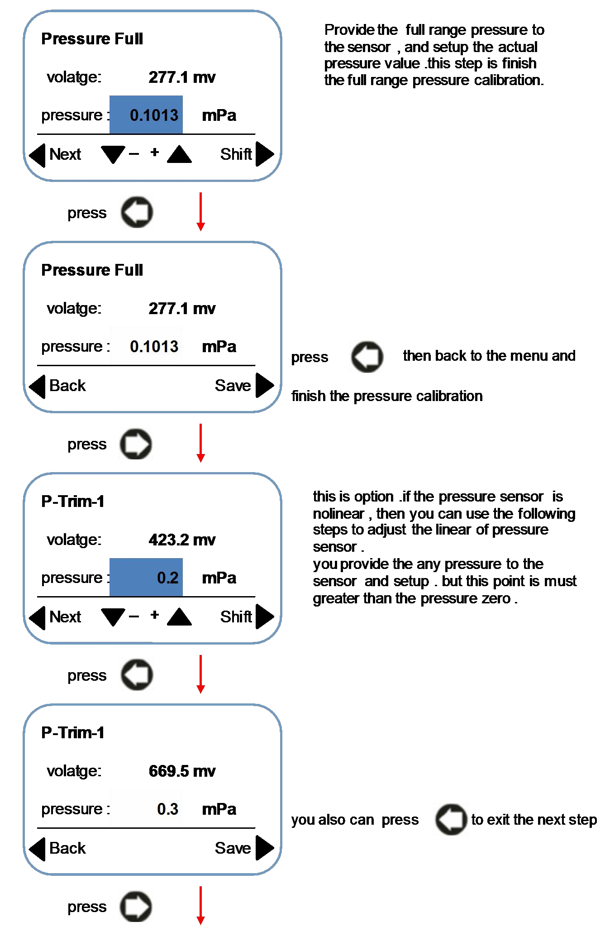

Pressure Adjust

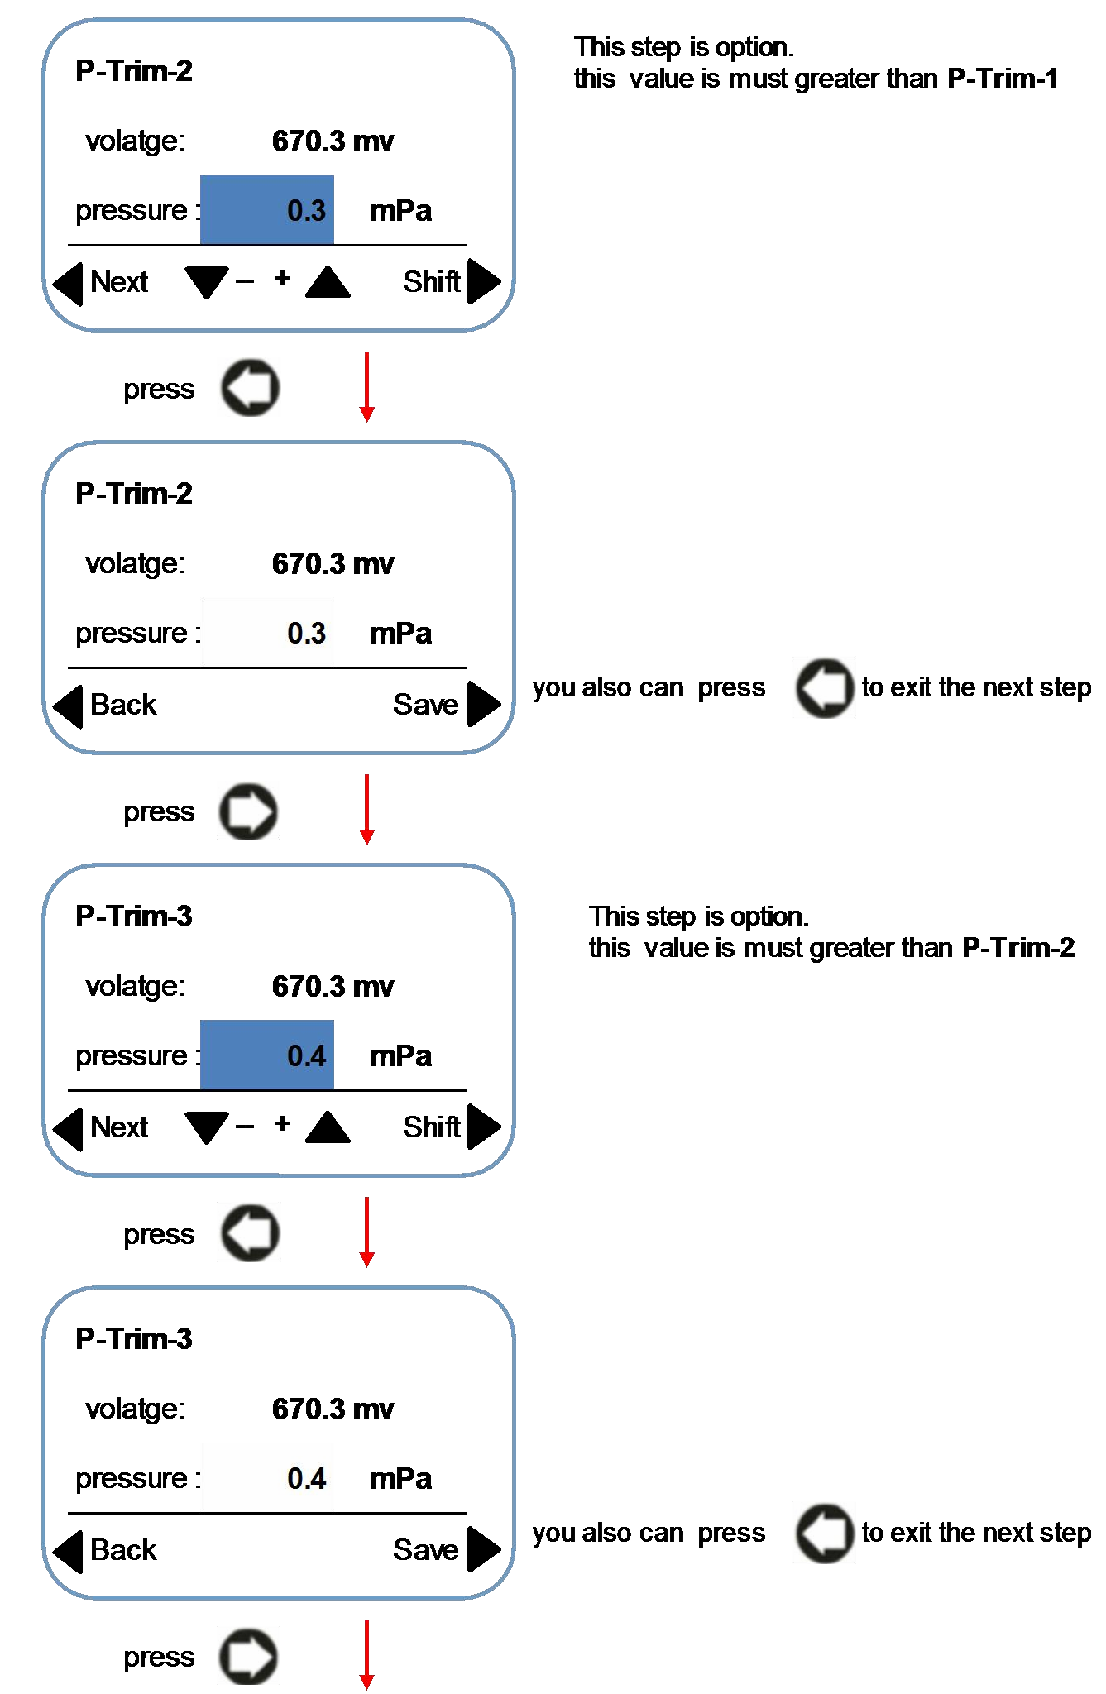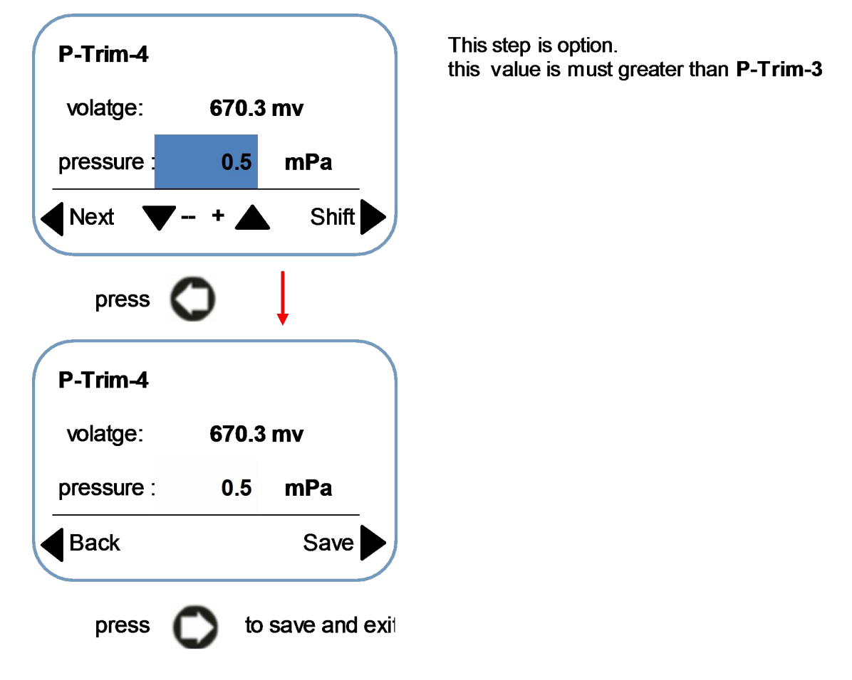

Pressure Adjust

### **Output Setup**：setup the parameter of pulse output or frequency output

|  |  |
| --- | --- |
| Max Frequency | Floating point： 5000.0 - 100.0 Hz ，default = 2000.0  **Output Frequency**（**Hz**）＝**flow rate**（**m3/h**）**÷ Flow range**（**m3/h**）**× Upper frequency limi**（**Hz**）  For example , the flowrate is 100m3/h, and the flow range is 200m3/h , and the “Max Frenquency ”is set to 2000HZ, then the output frequency is 1000HZ |
| Pulse equivalent | Floating point： 9999.0 – 0.0 ，default = 0.0  **The “pulse equivalent” unit is “liter per one pulse: L/P” , you also can change this unit to : USG/P ,Kg/P , t/P , Nm3/P , m3/P** |
| Pulse width（ms） | Floating point： 1000.0 ～ 0.0 ms ，default = 0.0  When this value is "0", the duty cycle of the output pulse is 1:1 |
| Signal | Indicates that the current output mode is a direct signal output, but this signal is filtered and Linearity modified. |

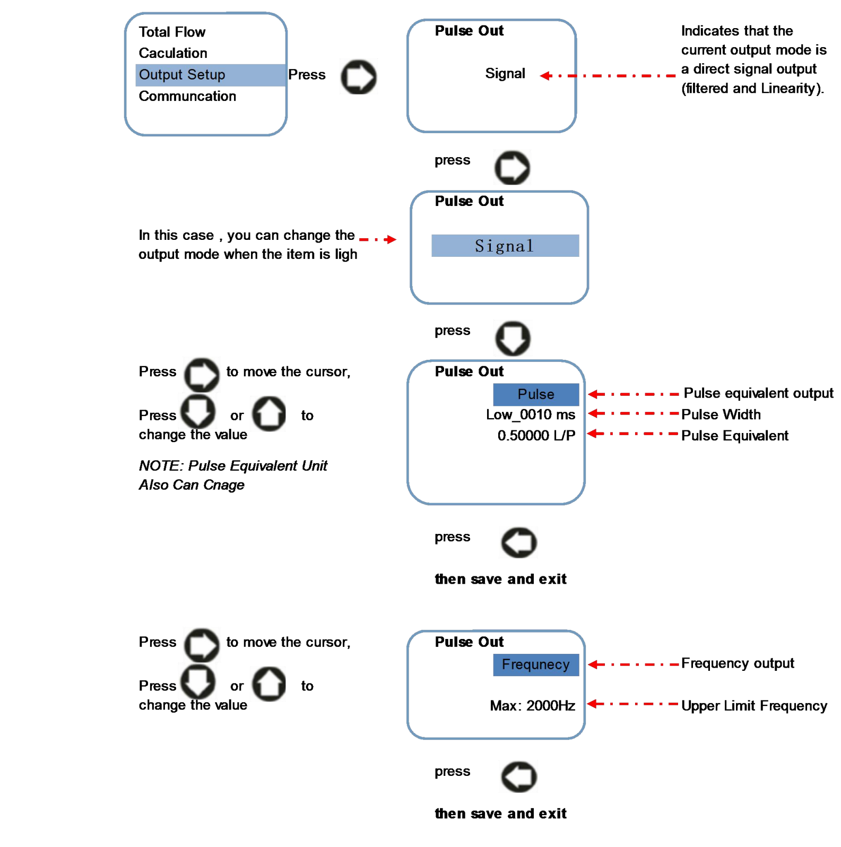

* **Communcation Setup**：setup RS485 communcation parameter

|  |  |
| --- | --- |
| Protocol | option: Modbus-RTU Modbus-ASCII default: Modbus-RTU |
| Baud Rate | option: 1200 2400 4800 9600 19200 38400  default = 19200  **Note: Please set the baud rate** ≥ **9600** |
| Data Bit | option: 7 8 ，default = 8  **Note: if use RTU protocol**，**prohibit to choose** “**7**” |

|  |  |  |  |  |
| --- | --- | --- | --- | --- |
| Check Mode | option: None , Odd , Even default = Even | | | |
| Device No | data: 247 | ～ | 1 | ，default = 1 |

* **Factory Parameter Setup**：Password **052500** . Setup the key parameters ,

|  |  |
| --- | --- |
| Medium | Option: **gas oper-flow** , **gas normal-flow**, **Liquid flow**  Default: **Liquid flow**  ***NOTE:***  **Gas oper-flow**: gas flow in working state  **Gas normal-flow**: gas flow in stardard state  **Liquid flow** : the fluid is liquid, like water etc.  **Choose different item , then deicde the different Algorithm in software** |
| Sensor Size | Option: 4，6，10，15、20、25、32、40、50、65、80、100、125、150、200、  250、300 mm  default value = 50 mm  for flange connection type liquid turbine flow meter, size is DN10 to DN200 for thread connection type liquid turbine flow meter, size is DN4 to DN65  For clamping connection type liquid turbine flow meter ,size is DN15 to DN50 For gas turbine flow meter,size is DN20 to DN300 |
| K-factor | Floating point： 9.9000～0.0100 ，default = 0.1  This parameter is determined when the real flow calibration is carried out. This parameter is only related to the sensor, which indicates the characteristic value of the sensor.  **Q** (flow rate,m3/h) ＝ **3600** × **F**(frequency,HZ) ÷ **k** (k-factor)  **After you finished the test , then need setup the final K-fator at here. K (k-factor) : Numbers of pulse per m3** |

|  |  |
| --- | --- |
| Linearity | After finish the first point setup , then setup “linearity 2 “.  **Note: you must setup the biggest frequency of test as the “linearity 1”. Setup from big frequency to small frequency.** |
| Density | Float point： 999999～0.1 kg/m3 ，default = 1000.0 kg/m3  **This parameter is only use for liquid and need mass flow meter . For gas , have no any function, use for liquid only and Kg unit** |

|  |  |
| --- | --- |
| Pressure Type  *(for gar turbine flow meter)* | Choose the pressure sensor type . only *for gar turbine flow meter*  Option: absolute, gauge and fix pressure value Default :absolute    **If you do not install the pressure sensor , you can setup the “fix pressure value” .but this fix pressure value is gauge only .** |
| Temp. Type *(for gar turbine flow meter)* | Choose the temperature sensor type . *(for gar turbine flow meter)*  Option:Pt1000 , Pt100 and fix temperature value Default :Pt100  **Modified method is the same with “pressure type”** |
| Local atm. (Atmospheric Pressure) | Float point  Default :0.101 mPa  **If measure the liquid**，**then this parameter have no affect.** |
| STP.Z | Gas compression coefficient in working state *(for gar turbine flow meter)*  Default : 1.000  **If measure the liquid , then this parameter have no affect.** |
| Normal.Z | Gas compression coefficient in stardard state *(for gar turbine flow meter)*  Default :1.000  **If measure the liquid , then this parameter have no affect.** |

## How to Setup The Parameter

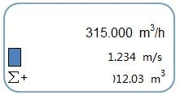

Figure 1: flow rate display interface pressto parameter setup menu，As shown in Figure 2：

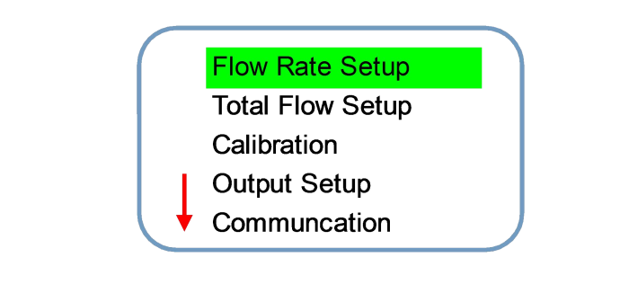Figure 2

After the interface is shown in Figure or then you can choose different set items。

Press then return to the flow display interface（figure 1）；

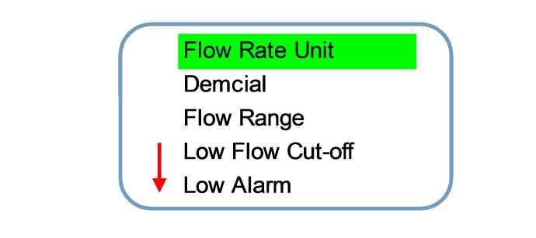Press or  move the cursor to the sub menu，press go to sub menu to setup the parameter， for example , we need setup the “flowrate parameter”，when this item become , then will display the menu as shown in figure 3 ：

Figure 3

Press or  to select the item which you want to modify，The selected item will brighten，if need return to the menu as shown in figure 2，then press；If you need to enter the next level of items，then press to setup the parameters as shown in figure 4：

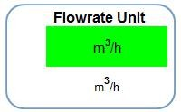

Figure 4

In this case , press  or to modify the parameter ， for example, as shown in figure 4, you need change the flowrate unit from **" m³/h ”** to **" m³/m ”**，then ，the flowrate unit will become to **“ m³/m ”**， as shown in figure 5：

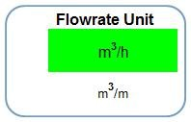

Figure 5

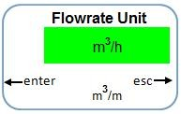After you modify the parameter , if you need save,then ，The system will prompt the "confirmation" and "exit" option, as shown in Figure 6：

图 6

In this ，then save the setup and back（as shown in figure 3）；if do not need save the parameter，then to back（as shown in figure 3）。



**Two Wire Mode Wiring**

# Wiring Diagram And Output Define

## 4-20mA Current Output Wiring Diagram

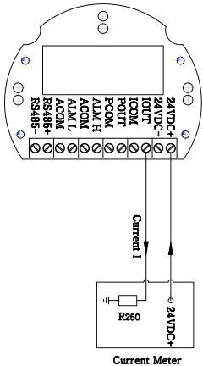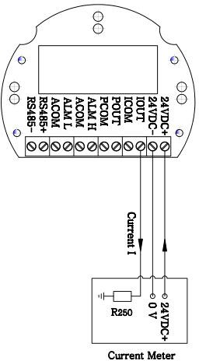

Current sensing resistor inside

the current meter

**Three Wire Mode Wiring**

**Terminal Board**

**Terminal Board**

#### The Define of Each Terminal

|  |  |  |
| --- | --- | --- |
| **Terminal Symbol** | **Funcation** | **Remarks** |
| 24V **+** | DC 18 - 36V **+** | Power supply 24V + |
| 24 **-** | DC 18~36v **-** | Power supply 24V **-** |
| IOUT | 4~20Ma **+** | The load resistance is less than or equal  to 500.ohm |
| ICOM | 4~20mA **-** |
| POUT | Frequency & Pulse output **+** | |
| PCOM | Frequency & Pulse output **-** | |
| ALM **H** | High alarm output **+** | Suggest use 24VDC intermediate relay， Load current ≤ 30mA |
| ACOM | High alarm output **-** |
| ALM **L** | Low alarm output **+** |
| ACOM | low alarm output **-** |
| RS+ | RS485 **+** | RS485 terminal |
| RS- | RS485 **-** |

* 1. **Pulse Output Wiring Diagram**

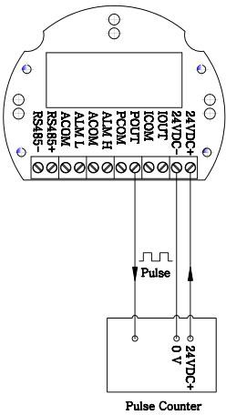

**Terminal Board**

* 1. **Wiring Between Transmitter And Sensor**

Terminal Denfine of Main Board

|  |  |  |
| --- | --- | --- |
| **Terminal Symbol** | **Function** | **Remarks** |
| SIGA | Signal terminal 1 of turbine meter sensor | |
| SIGB | Signal terminal 2 of turbine flow meter sensor | |
| V+ | Power (**+**) to pressure sensor | Connect to pressure sensor |
| V- | Power (**-**) to pressure sensor |
| P+ | Signal(+) of pressure output |
| P- | Signal(-) of pressure output |
| RTD+ | Thermal resistance | Pt100 or Pt1000, two-wire |
| RTD- | Thermal resistance |

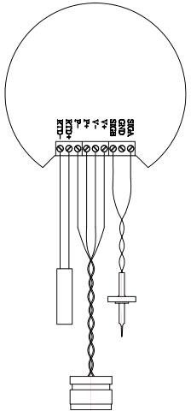

Blue Wire

Red Wire

Flow Sensor

White Wire

Black Wire

Pressure Sensor

Temperature Sensor Pt100/Pt1000

**Turbine Flow Meter**

**Main Board**

* 1. **Frequency Output Mode**：

Frequency output range is 0 to 5000HZ, the frequency output corresponds to the percentage of flowrate.

*F*  *F*low *Rate Flow Range*

*Upper Frequency Limit*

Frequency output mode is generally used to control the occasion, because it reflects the percentage of traffic, if the user is used for measurement occasions, it should choose the pulse output mode。

The frequency output is provided with an internal 24VDC power supply and NPN way。

#### If you need use the frequency output mode , then three parameters must setup:

* + - **Setup “Max frequency” in outpur menu**
    - **Setup “flow range” (corresponding to max frequency) in flow rate setup menu**
  1. **Pulse Equivalent Output Mode**：

Pulse equivalent value：0.001L，0.01L，0.1L，1L，0.001 M3 。The user should pay attention to the matching of the flow range and the pulse equivalent when selecting the pulse equivalent。If the flowrate is too large and the

pulse equivalent selection is too small, it will cause the upper limit of the pulse output, so the pulse output

frequency should be limited to the following 3000Hz. If the flowrate is small and the pulse equivalent is too large, it will cause the meter to output a pulse for a long time 。 In addition, it must be explained that the pulse output is different with the frequency output, the pulse output is a pulse equivalent to output a pulse, therefore, the pulse

output is not very uniform. The general measurement of the pulse should use the counter meter, not choose the frequency meter。

The pulse output is provided with an internal 24VDC power supply and NPN way。

## Analog Output Mode（4-20Ma）

The current output corresponds to the percentage of instantaneous flow。The current output is provided with an internal 24VDC power supply.。

*I*0 

*F*low *Rate Flow Range*

### 16  4.0

For 4 ~ 20mA signal system, the current zero is 4mA. Therefore, in order to improve the resolution of the output analog current, the flow range of the flowmeter should be selected properly.

# Key Points of Attention

Go to <Factory Setup>, choose the “**Medium**”, this is very important Go to <Factory Setup>, choose the “**Sensor Size**”.

Go to <Flow Rate Setup>, setup the flow Range, unit and another parameters Go to <Output setup>, choose the output mode and parameters

**Appendix "RS485 Communication Address Table**

**Instrument variable address definition**

The following is a list of data variables that are supported by the instrument, the data are HEX type

|  |  |  |  |  |
| --- | --- | --- | --- | --- |
| **Variable name** | **Register start**  **address** | **Register length** | **Instruction Code** | **Data Type** |
| Flow Rate | 0x01 | 0x02 | 0x04 | float |
| Flow Rate Unit | 0x03 | 0x01 | 0x04 | int |
| Total Flow | 0x04 | 0x04 | 0x04 | double |
| Total Flow Unit | 0x08 | 0x01 | 0x04 | int |
| Temperature | 0x09 | 0x02 | 0x04 | float |
| Pressure | 0x0b | 0x02 | 0x04 | float |
| Total Flow(m3) | 0x0d | 0x02 | 0x03 0x04 | float |
|  |  |  |  |  |
| Flow Rate | 0x14 | 0x02 | 0x04 | float |
| Total Flow | 0x16 | 0x02 | 0x04 | float |
| Temperature | 0x18 | 0x02 | 0x04 | float |
| Pressure | 0x1a | 0x02 | 0x04 | float |
|  |  |  |  |  |
| Flow Rate | 0x1e | 0x02 | 0x04 | float inverse |
| Total Flow | 0x20 | 0x02 | 0x04 | float inverse |
| Temperature | 0x22 | 0x02 | 0x04 | float inverse |
| Pressure | 0x24 | 0x02 | 0x04 | float inverse |

## Definition of Common Units

|  |  |  |
| --- | --- | --- |
| Flow Rate | Unit Name | Code |
| Nm3/h | 0x00 |
| Nm3/m | 0x01 |
| Nm3/s | 0x02 |
| m3/h | 0x03 |
| m3/m | 0x04 |
| m3/s | 0x05 |
| L/h | 0x06 |
| L/m | 0x07 |
| L/s | 0x08 |
| usg/h | 0x09 |
| usg/m | 0x0a |
| usg/s | 0x0b |
| kg/h | 0x0c |
| kg/m | 0x0d |
| kg/s | 0x0e |
| t/h | 0x0f |
| t/m | 0x10 |
| t/s | 0x11 |

|  |  |  |
| --- | --- | --- |
| Total Flow | Nm3 | 0x00 |
| m3 | 0x01 |
| L | 0x02 |
| usg | 0x03 |
| kg | 0x04 |
| t | 0x05 |